|  |
| --- |
| **Activity 1.2.3 Circuits – Simulation** |

Electric Circuit Schematics

Schematics are diagrams consisting of symbol representations and configurations of electrical components within a circuit. The table below illustrates circuit symbols to be used within schematics throughout this lab.

|  |  |  |
| --- | --- | --- |
| Component | Symbol | Pictorial |
| Power supply  (Battery) |  |  |
| Conductive wire |  |  |
| Resistor |  |  |
| Open switch  Closed switch |  |  |
| Light bulb |  |  |
| Voltmeter  *(Voltage readings)*  *V* |  |  |
| Ammeter  *(Current readings)*  I |  |  |

Constructing Circuits

Your team will construct a series and parallel circuit using the steps provided below.

Creating a Circuit

1. Launch Circuit Construction Kit from University of Colorado at Boulder: http://phet.colorado.edu/en/simulation/circuit-construction-kit-dc
2. Drag a battery from the circuit palate on the right. R-click on the battery and set the voltage to 9 volts.

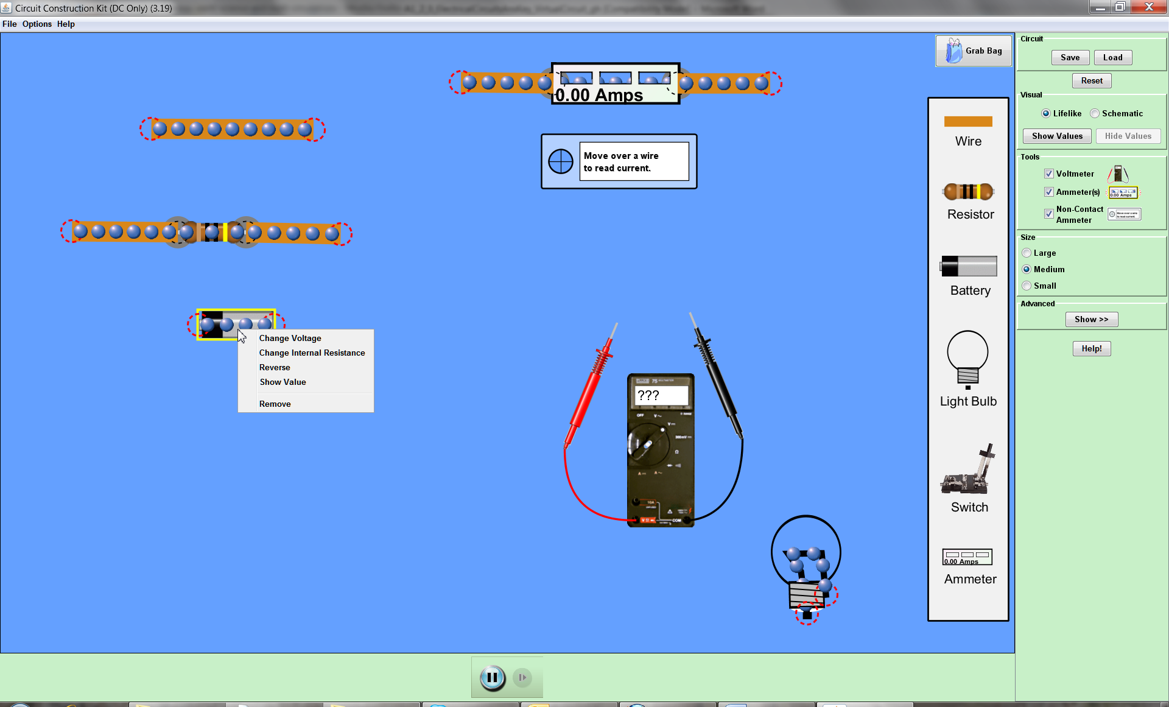

1. Construct the circuit displayed below using the default bulb and a switch in the open position. Note that your circuit will not look like the image below. You are to interpret the schematic diagram to create a circuit. Check the voltage across the light bulb. Record the measurements in the space provided below.

**NOTE:** When measuring voltage getting a positive or negative value is dependent upon polarity or direction of flow. In other words, the 4.5V and -4.5V could be taken from the same source depending on placement of the leads.

|  |  |
| --- | --- |
|  |  |

1. Close the switch so the bulb remains on. Obtain the voltage measurements across the bulb and the power supply. Record the measurements in the space provided below.

Bulb _____9__V Power supply ____9______V

1. Check the current through the light bulb by adding an ammeter. Record the measurements in the space provided below.

|  |  |
| --- | --- |
|  | Current _________0.9____A |

1. Use the voltage (V) and current that you have already determined for this circuit current (I) to determine the resistance of the bulb. Show your work and include units.

Formula: a=v/Ohms Substitute values: 0.9 = 9/x

Solve:0.9 = 9/10

Resistance = ________10_______Ω

Creating a Series Circuit

1. Use the image below to create a series circuit.

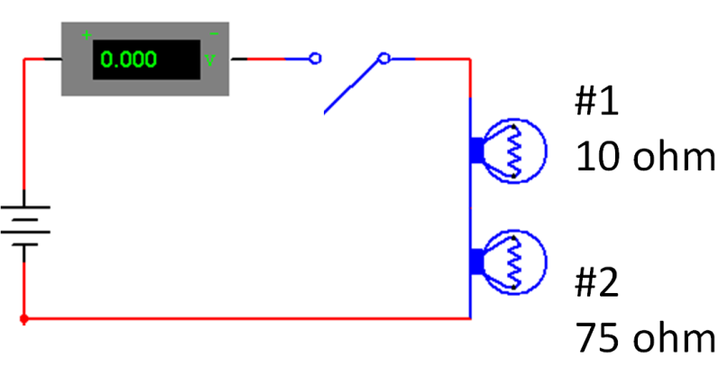

1. Close the switch. Record the readings for the circuit.

Current _________0.11_____A Voltage across battery ___9______V

Voltage across bulb #1 _____1.06____V Voltage across bulb #2 ___7.94____V

Add an ammeter between the bulbs and record the current.

Current between bulbs _______0.11_______A

1. Use the voltage (V) and current that you have already determined for this series circuit current (I) to determine the resistance of the bulbs in series. Show your work and include units.

Formula: a = v/c Substitute values: 0.11 = 1.06/x

Solve: I = 0.8734

Resistance = ________0.99_______Ω

Creating a Parallel Circuit

1. Create the circuit shown below with the switch open. Confirm that: bulb 1 is on and bulb 2 is off.

|  |
| --- |
|  |

Close the switch and record the following data.

|  |
| --- |
| What happened to brightness of the 1st bulb? ________________No change______________  Which bulb is brighter? ______________The first______________  Current at bulb #1 _____0.9_________A  Current at bulb #2 _____0.12_________A |
| Current total _______2.04________A |
|  |

1. Add a voltmeter to the circuit. Record the voltages across each light and the output source in the space provided below.

Bulb #1 _______9_________V Bulb #2 ________9_________V

Output at the battery _____9___________V

1. Calculate total resistance for the circuit (show all work):  
     
   Formula: a = v/c  
     
   Substitute and solve:   
     
   RT_____2.04 = 9/x = 18.36_____ Ω

Creating a Combination Circuit

1. Create the circuit shown below. The bulb #1 should still be on, the current meter should have the same measurement as in step 8, and the bulb #2 and #3 should be off. Close the switch button and note what happens to the first light. Refer to the image below and record the new current measurement in the space provided below the image.

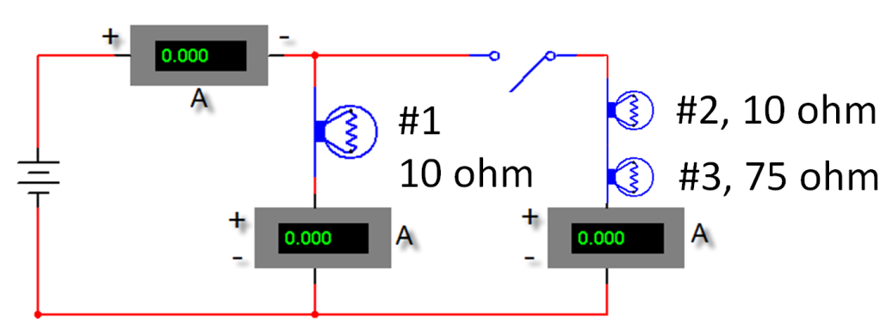

Voltage across battery ___9______V

Voltage across bulb #1 _____9____V Voltage across bulb #2 ___1.06____V

Voltage across bulb #3 ___7.94____V

Current at bulb #1 ______0.90________A

Current at bulb #2 and #3 ______0.11________A

2.02

Total current ______________A **Conclusion**

1. Explain the primary difference between a series and a parallel circuit.

A parallel circuit allos for current to pass through all connected parts however a series closes or turns the current off when there is an open circuit.

1. Explain the difference between the voltage output at the battery and the voltage across each bulb in the series circuit.

Series – Voltage remains unchanged

1. In a series circuit, explain the relationship between the current at the battery and each bulb in the circuit.

In a series, the voltage will remain the same.

1. Explain the relationship between voltage at the battery and voltage across each bulb in a parallel circuit.

Because there are multiple paths for the volts to take, the voltage will decrease.

1. Explain the relationship between current at the battery and current through each bulb in the parallel circuit.

The current at the bulb should be the same as the voltage near the battery. However, the current will decrease when it passes the bulb.

1. For the combination circuit, explain the relationship between the *voltage* output at the interface and the voltage across the two light bulbs.

Bulb 2 and 3 willl share a particular voltage.

1. For the combination circuit, explain the relationship between the *current* output at the battery and the current through each bulb in the parallel circuit.

Because of more resistance, less current passes through 2 and 3.